Ayush Goyal
190905522 CSE D 62

Distributed Systems Week 6: Lab 6: Clock Synchronization

Lab Exercises:

1. The Manipal Foodie is a renowned automated food processing outlet known for its tiffin service to students. The various processes involved are food production, filling and packing. Every day more than 3000 orders are received on an average from the students inmanipal. There are total of 4 production lines for orders received from KMC, MIT, TAPMI and SOLS students, each of them has a digital clock which needs to be in synchroniza tion with the master clock. The master clock mounted in the testing lab controls the entire clock system. Design an appropriate solution using Berkeley’salgorithm for the above scenario. Assume that the clocks at the institutes are slave/clients.

Code:

1server.py:

from functools import reduce
from dateutil import parser
import threading
import datetime
import socket
import time
client_data = {}

def startRecieveingClockTime(connector, address):
while True:
clock_time_string = connector.recv(1024).decode()
clock_time = parser.parse(clock_time_string)
clock_time_diff = datetime.datetime.now() - clock_time
client_data[address] = {
"clock_time" : clock_time,
"time_difference" : clock_time_diff,
"connector" : connector
}
print("Client Data updated with: "+ str(address), end = "\n\n")
time.sleep(5)

def startConnecting(master_server):
while True:
master_slave_connector, addr = master_server.accept()
slave_address = str(addr[0]) + ":" + str(addr[1])
print(slave_address + " got connected successfully")
current_thread = threading.Thread(
target = startRecieveingClockTime,
args = (master_slave_connector, slave_address, ))
current_thread.start()

def getAverageClockDiff():
current_client_data = client_data.copy()
time_difference_list = list(client['time_difference'] for client_addr, client in
client_data.items())
sum_of_clock_difference = sum(time_difference_list, datetime.timedelta(0, 0))
average_clock_difference = sum_of_clock_difference / len(client_data)
return average_clock_difference

def synchronizeAllClocks():
while True:
print("New synchroniztion cycle started.")
print("Number of clients to be synchronized: " + str(len(client_data)))
if len(client_data) > 0:
average_clock_difference = getAverageClockDiff()
for client_addr, client in client_data.items():
try:
synchronized_time = datetime.datetime.now() + average_clock_difference
client['connector'].send(str(synchronized_time).encode())
except Exception as e:
print("Something went wrong while sending synchronized time through " + str(client_addr))
else :
print("No client data. Synchronization not applicable.")
print("\n\n")
time.sleep(5)

def initiateClockServer(port = 8080):
master_server = socket.socket()
master_server.setsockopt(socket.SOL_SOCKET, socket.SO_REUSEADDR, 1)
print("The Manipal Foodie\n")
master_server.bind(('', port))
master_server.listen(10)
print("Clock server print\n")
print("Connecitng to production lines...\n")
master_thread = threading.Thread(
target = startConnecting,
args = (master_server, ))
master_thread.start()
print("Starting synchronization parallely...\n")
sync_thread = threading.Thread(
target = synchronizeAllClocks,
args = ())
sync_thread.start()

if __name__ == '__main__':
initiateClockServer(port = 8080)

1mit.py:

from timeit import default_timer as timer
from dateutil import parser
import threading
import datetime
import socket
import time

def startSendingTime(slave_client):
while True:
slave_client.send(str(datetime.datetime.now()).encode())
print("MIT time sent successfully", end = "\n\n")
time.sleep(5)

def startReceivingTime(slave_client):
while True:
Synchronized_time = parser.parse(slave_client.recv(1024).decode())
print("Synchronized time at the client is: " + str(Synchronized_time), end = "\n\n")

def initiateSlaveClient(port = 8080):
slave_client = socket.socket()
slave_client.connect(('127.0.0.1', port))
print("Starting to receive time from server\n")
send_time_thread = threading.Thread(
target = startSendingTime,
args = (slave_client, ))
send_time_thread.start()
print("Starting to recieving synchronized time from server\n")
receive_time_thread = threading.Thread(
target = startReceivingTime,
args = (slave_client, ))
receive_time_thread.start()

if __name__ == '__main__':
initiateSlaveClient(port = 8080)

1kmc.py:

from timeit import default_timer as timer
from dateutil import parser
import threading
import datetime
import socket
import time

def startSendingTime(slave_client):
while True:
slave_client.send(str(datetime.datetime.now()).encode())
print("KMC time sent successfully", end = "\n\n")
time.sleep(5)

def startReceivingTime(slave_client):
while True:
Synchronized_time = parser.parse(slave_client.recv(1024).decode())
print("Synchronized time at the client is: " + str(Synchronized_time), end = "\n\n")

def initiateSlaveClient(port = 8080):
slave_client = socket.socket()
slave_client.connect(('127.0.0.1', port))
print("Starting to receive time from server\n")
send_time_thread = threading.Thread(
target = startSendingTime,
args = (slave_client, ))
send_time_thread.start()
print("Starting to recieving synchronized time from server\n")
receive_time_thread = threading.Thread(
target = startReceivingTime,
args = (slave_client, ))
receive_time_thread.start()

if __name__ == '__main__':
initiateSlaveClient(port = 8080)

1tapmi.py:

from timeit import default_timer as timer
from dateutil import parser
import threading
import datetime
import socket
import time

def startSendingTime(slave_client):
while True:
slave_client.send(str(datetime.datetime.now()).encode())
print("TAPMI time sent successfully", end = "\n\n")
time.sleep(5)

def startReceivingTime(slave_client):
while True:
Synchronized_time = parser.parse(slave_client.recv(1024).decode())
print("Synchronized time at the client is: " + str(Synchronized_time), end = "\n\n")

def initiateSlaveClient(port = 8080):
slave_client = socket.socket()
slave_client.connect(('127.0.0.1', port))
print("Starting to receive time from server\n")
send_time_thread = threading.Thread(
target = startSendingTime,
args = (slave_client, ))
send_time_thread.start()
print("Starting to recieving synchronized time from server\n")
receive_time_thread = threading.Thread(
target = startReceivingTime,
args = (slave_client, ))
receive_time_thread.start()

if __name__ == '__main__':
initiateSlaveClient(port = 8080)

1sols.py:

from timeit import default_timer as timer
from dateutil import parser
import threading
import datetime
import socket
import time

def startSendingTime(slave_client):
while True:
slave_client.send(str(datetime.datetime.now()).encode())
print("SOLS time sent successfully", end = "\n\n")
time.sleep(5)

def startReceivingTime(slave_client):
while True:
Synchronized_time = parser.parse(slave_client.recv(1024).decode())
print("Synchronized time at the client is: " + str(Synchronized_time), end = "\n\n")

def initiateSlaveClient(port = 8080):
slave_client = socket.socket()
slave_client.connect(('127.0.0.1', port))
print("Starting to receive time from server\n")
send_time_thread = threading.Thread(
target = startSendingTime,
args = (slave_client, ))
send_time_thread.start()
print("Starting to recieving synchronized time from server\n")
receive_time_thread = threading.Thread(
target = startReceivingTime,
args = (slave_client, ))
receive_time_thread.start()

if __name__ == '__main__':
initiateSlaveClient(port = 8080)

OUTPUT:

Firstly, we run the server code in one terminal and thus the server will be active. After that we start running each of the four clients one by one.

After running 1server.py:

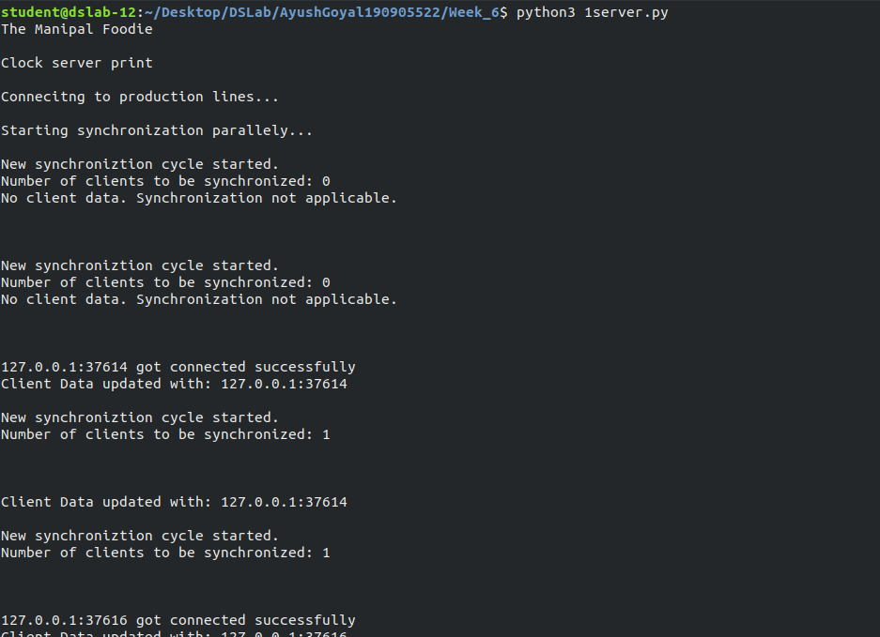

After running 1mit.py:

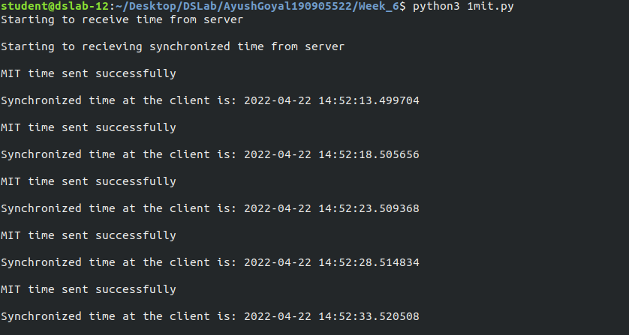

After running 1kmc.py:

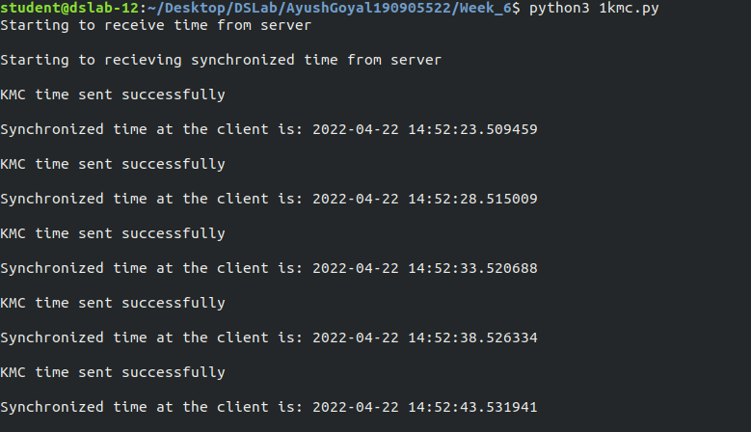

After running 1tapmi.py:

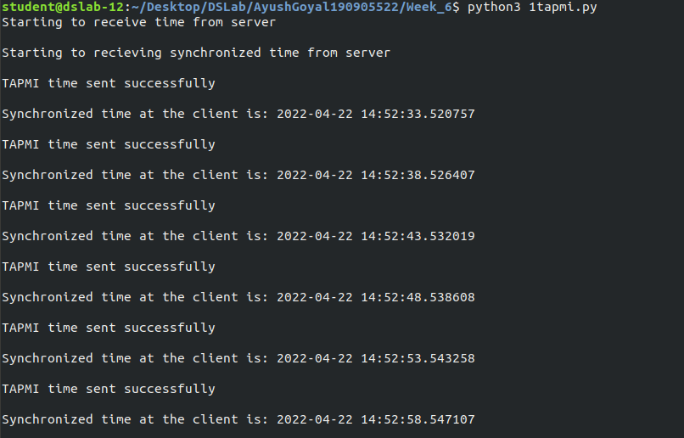

After running 1sols.py:

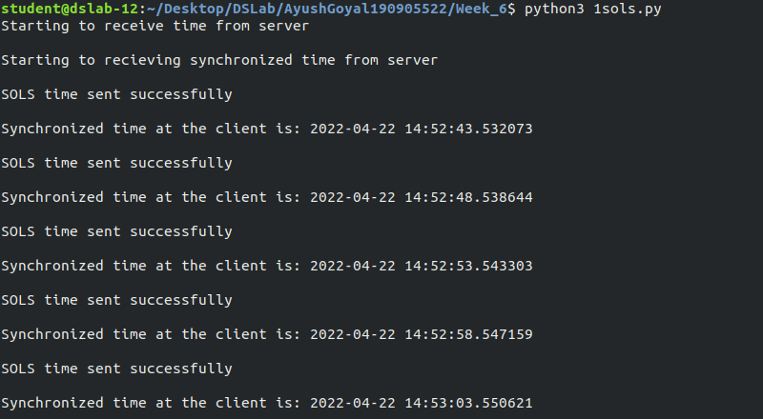

Finally, we can see the output of 1server.py terminals as:

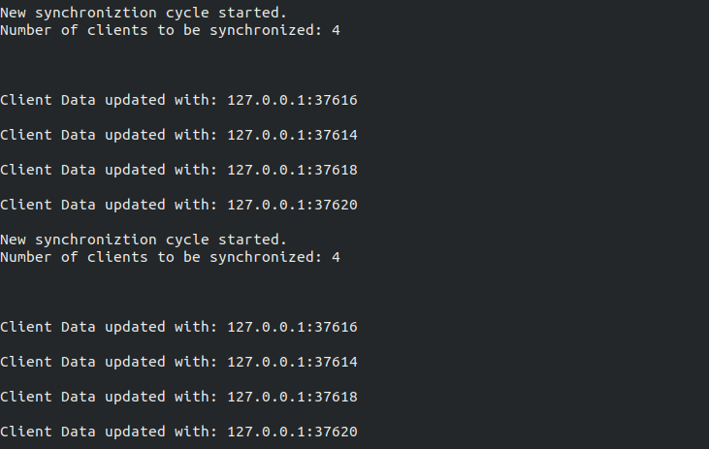

2. Manipal Buddy is a banking and education application for the students and staff of MIT, Manipal. Mr Vinay, a sixth semester student wants to pay the end semester exams fees for a re-registered course. He simultaneous ly wishes to register for a course on NPTEL through the app. To register for exam he uses the mobile app whereas to register for NPTEL course he uses his laptop to log in. As he needs to finish both the registrations on the same day, he tries to do both the tasks simultaneous ly. Analyse and demonstrate using a program how Cristian’s algorithm can be used in the above case to synchronize the clocks. Assume the relevant parameters.

Code:

2server.py:

import socket
import datetime
import time

def initiateClockServer():
s = socket.socket()
print("Manipal Buddy Banking")
port = 8011
s.bind(('', port))
s.listen(5)
print("Waiting for client...")
while True:
connection, address = s.accept()
print('Server connected to', address)
connection.send(str(datetime.datetime.now()).encode())
connection.close()

if __name__ == '__main__':
initiateClockServer()

2client1-mobileapp-examfees.py:

import socket
import datetime
import time
from dateutil import parser
from timeit import default_timer as timer

def synchronizeTime():
print("MOBILE APP\n")
s = socket.socket()
port = 8011
s.connect(('127.0.0.1', port))
request_time = timer()
server_time = parser.parse(s.recv(1024).decode())
response_time = timer()
actual_time = datetime.datetime.now()
print("Time returned by server: " + str(server_time))
process_delay_latency = response_time - request_time
print("Process Delay latency: " + str(process_delay_latency) + " seconds")
print("Actual clock time at client side: " + str(actual_time))
client_time = server_time + datetime.timedelta(seconds = (process_delay_latency) / 2)
print("Synchronized process client time: " + str(client_time))
time.sleep(10)
s.close()

if __name__ == '__main__':
synchronizeTime()

2client2-webbrowser-NPTEL.py:

import socket
import datetime
import time
from dateutil import parser
from timeit import default_timer as timer

def synchronizeTime():
print("WEB BROWSER\n")
s = socket.socket()
port = 8011
s.connect(('127.0.0.1', port))
request_time = timer()
server_time = parser.parse(s.recv(1024).decode())
response_time = timer()
actual_time = datetime.datetime.now()
print("Time returned by server: " + str(server_time))
process_delay_latency = response_time - request_time
print("Process Delay latency: " + str(process_delay_latency) + " seconds")
print("Actual clock time at client side: " + str(actual_time))
client_time = server_time + datetime.timedelta(seconds = (process_delay_latency) / 2)
print("Synchronized process client time: " + str(client_time))
time.sleep(10)
s.close()

if __name__ == '__main__':
synchronizeTime()

OUTPUT:

Firstly, we run the server code in one terminal and thus the server will be active. After that we start running the two clients one by one.

After running 2server.py:

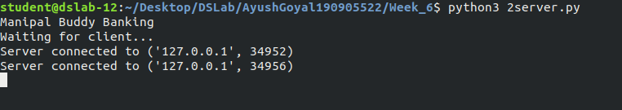

After running 2client1-mobileapp-examfees.py:

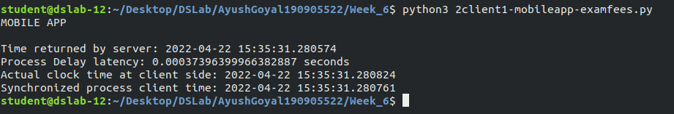

After running 2client2-webbrowser-NPTEL.py:

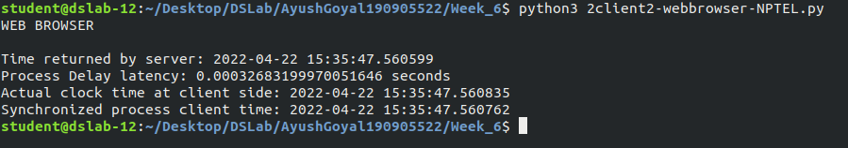

THE END

